# CHRONOLOGICAL READING

PLAN

**chronological**

## le in the order the eveogically.ill entire Bibl

C H R O N O L O G I C A L R E A D I N G P L A N 1

A S Y M P H O N Y O F P R A I S E

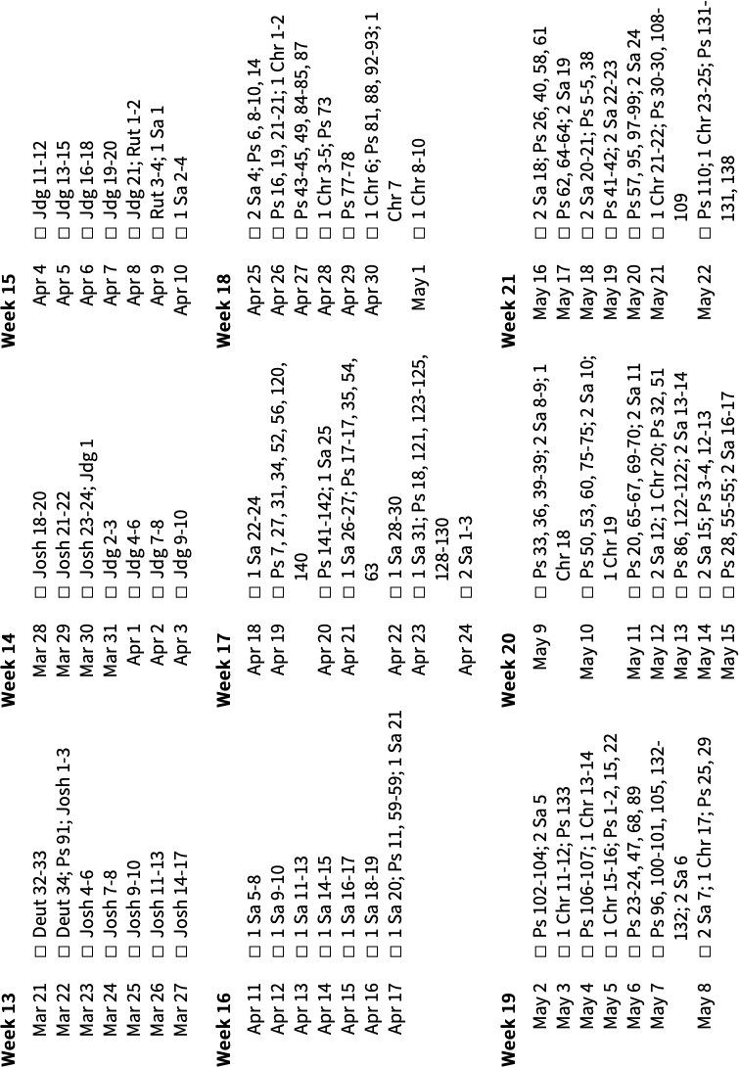

C H R O N O L O G I C A L R E A D I N G P L A N 2

A S Y M P H O N Y O F P R A I S E

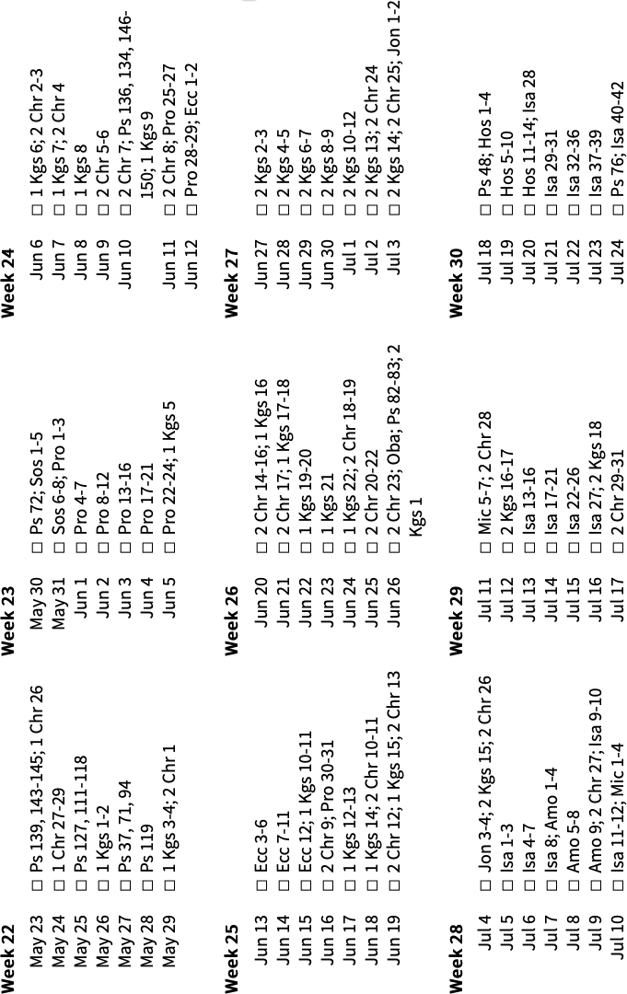

C H R O N O L O G I C A L R E A D I N G P L A N 3

A S Y M P H O N Y O F P R A I S E

C H R O N O L O G I C A L R E A D I N G P L A N 4

A S Y M P H O N Y O F P R A I S E

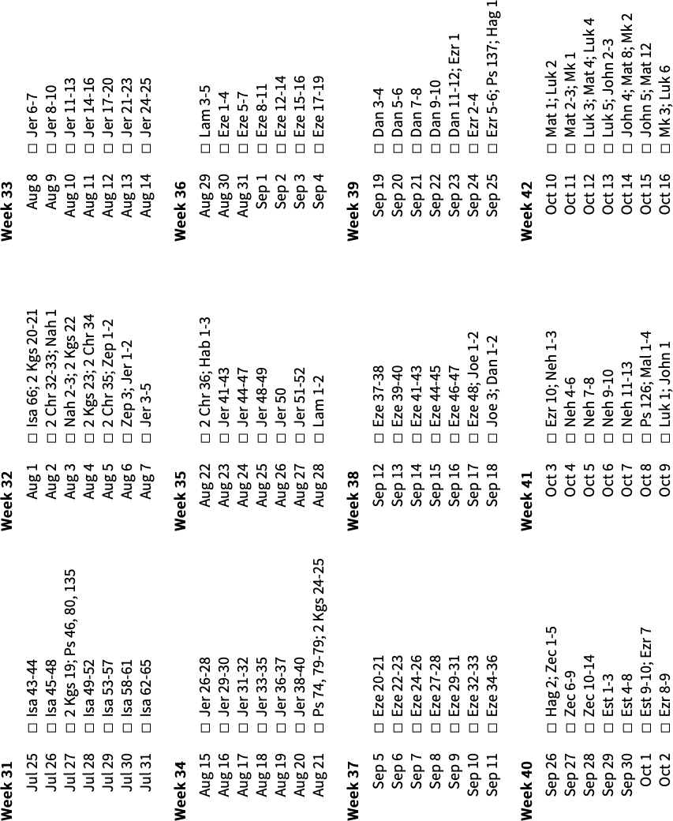

C H R O N O L O G I C A L R E A D I N G P L A N 5

A S Y M P H O N Y O F P R A I S E

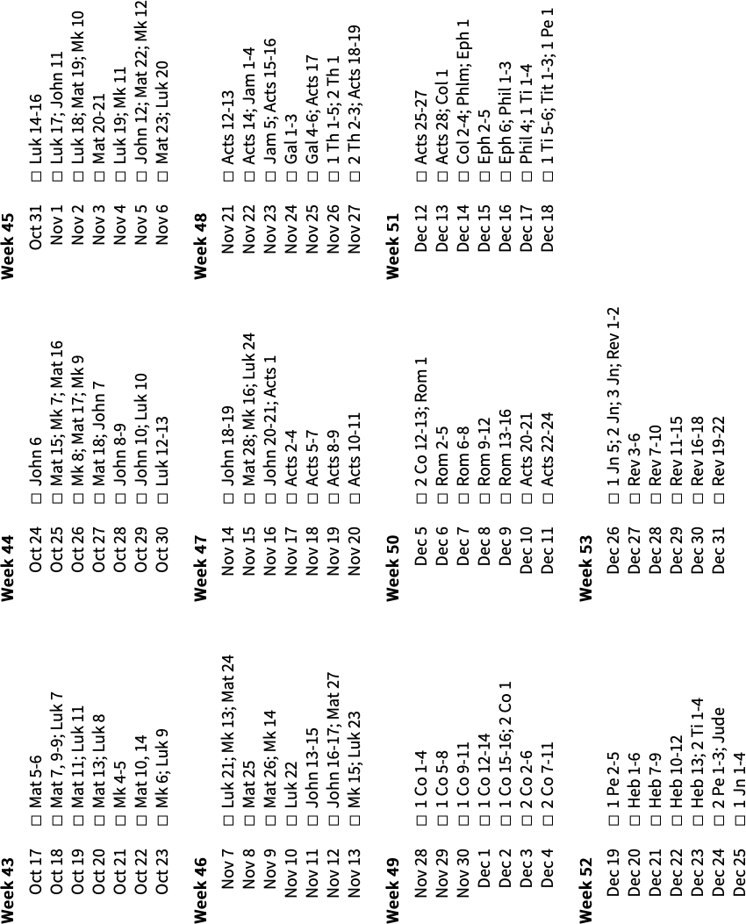

NOTES & THOUGHTS

B O O K N O T E S A S Y M P H O N Y O F P R A I S E

C H R O N O L O G I C A L R E A D I N G P L A N

A S Y M P H O N Y O F P R A I S E